MACH4METAL

metalworking machinery
Transito 21
6909 DA BABBERICH Netherlands
Tel. +31 (0)316-247123
Fax: +31 (0)316-247956
info@mach4metal.com
www.mach4metal.com

Bank No : 66.52.13.883
IBAN : NL33 INGB 0665 2138 83
BIC : INGBNL2A

LVD Press brake 1250 x 40 T
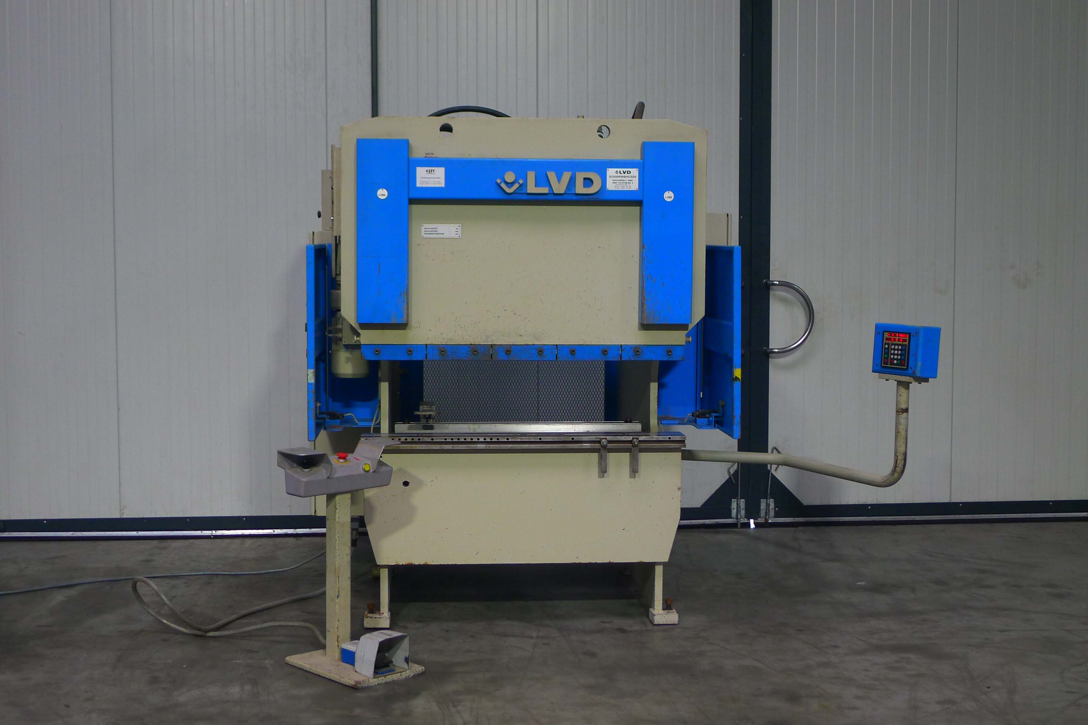

- Make : LVD - Belgium
- Typ : PPBL - H
- No : 22979
- Age : 02/1996

- Max. bending length: 1.250 mm
- Between column : 1.050 mm
- Max. force : 40 Ton
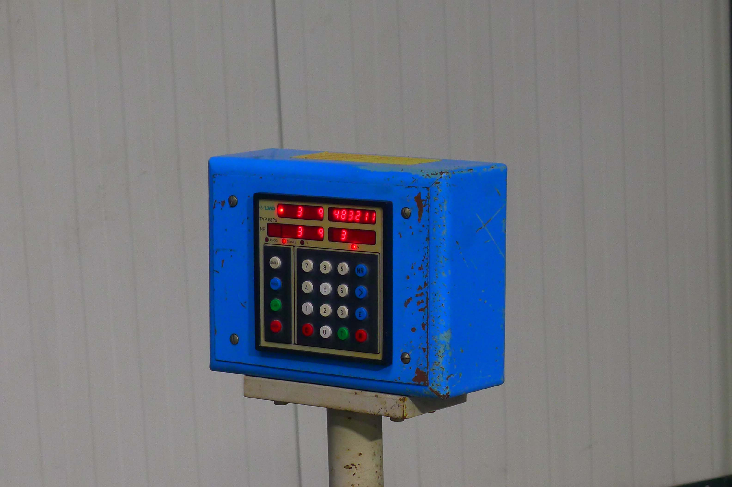

- Beam stroke : 100 mm
- Depth of throat : 205 mm
- Table width : 140 mm

- Approach speed : 80 mm/min
- Bending speed : 10 mm/min
- Return speed : 90 mm/min
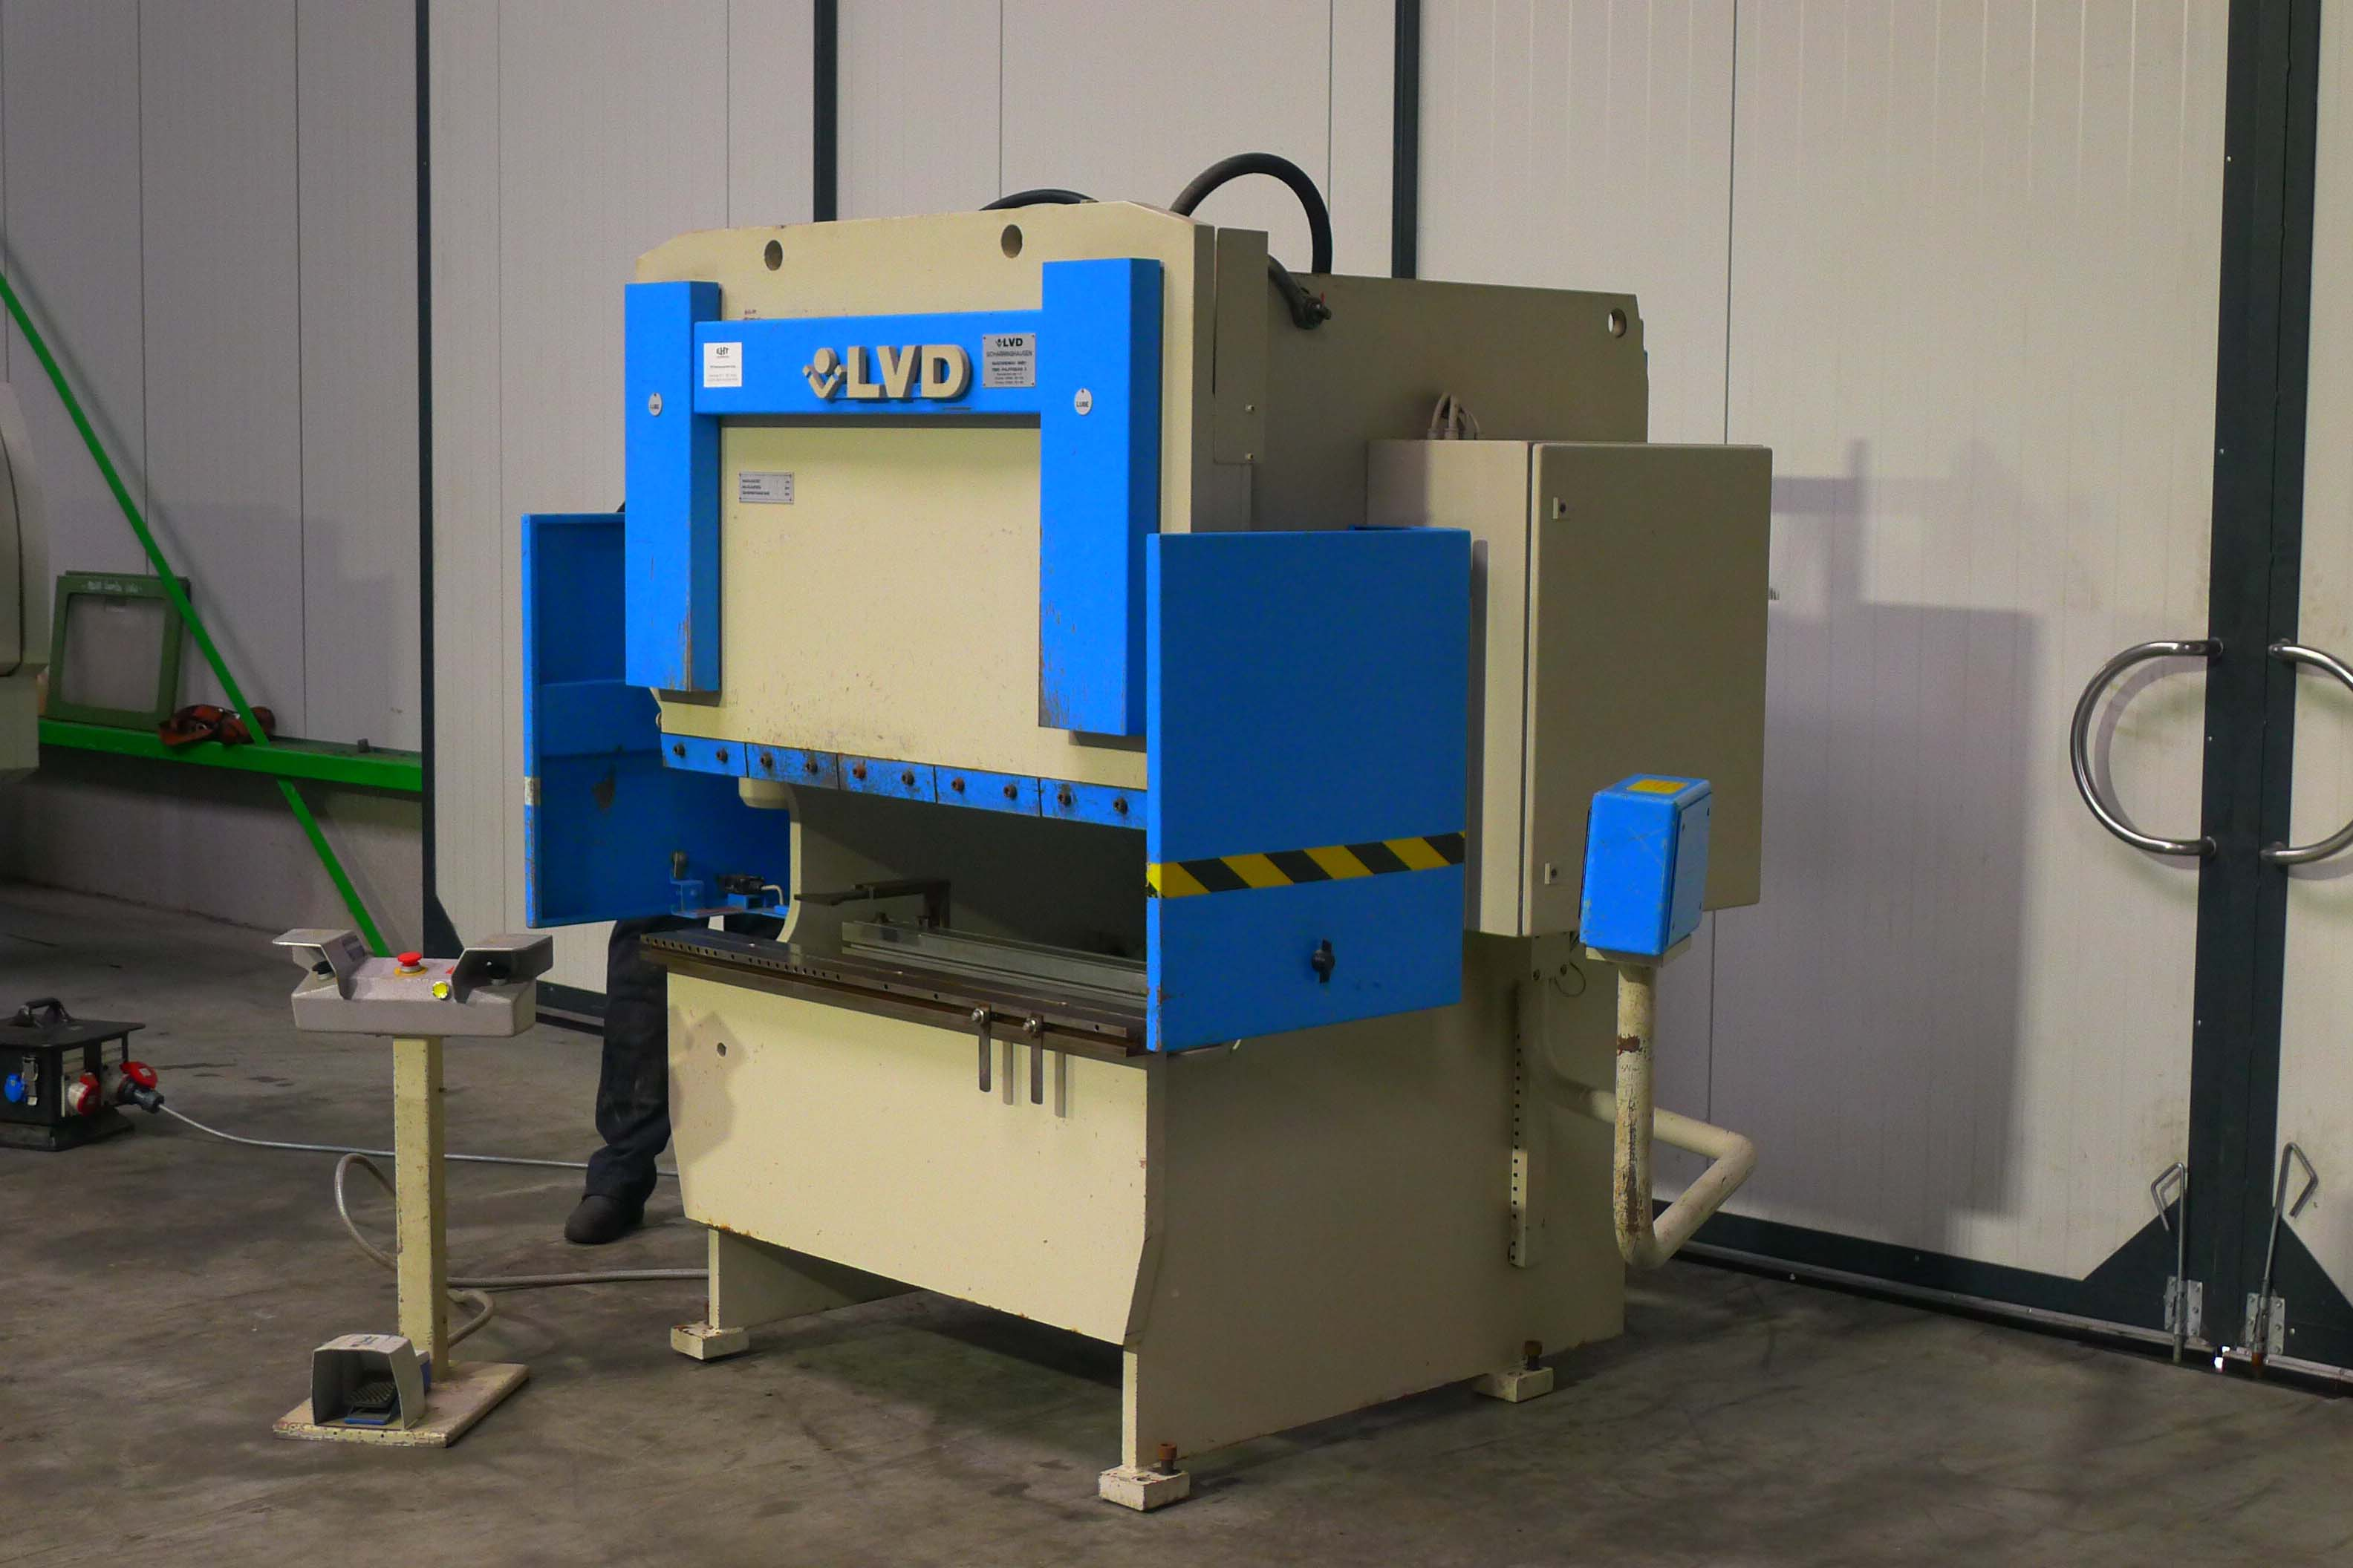
- ELGO 88 P backgauge
- Depth ca. 1.000 mm

- Dimensions
- Length : 1.550
- Width : 1.305
- Height : 1.980
- Weight : 2.000

- Power 400 V / 4 kW
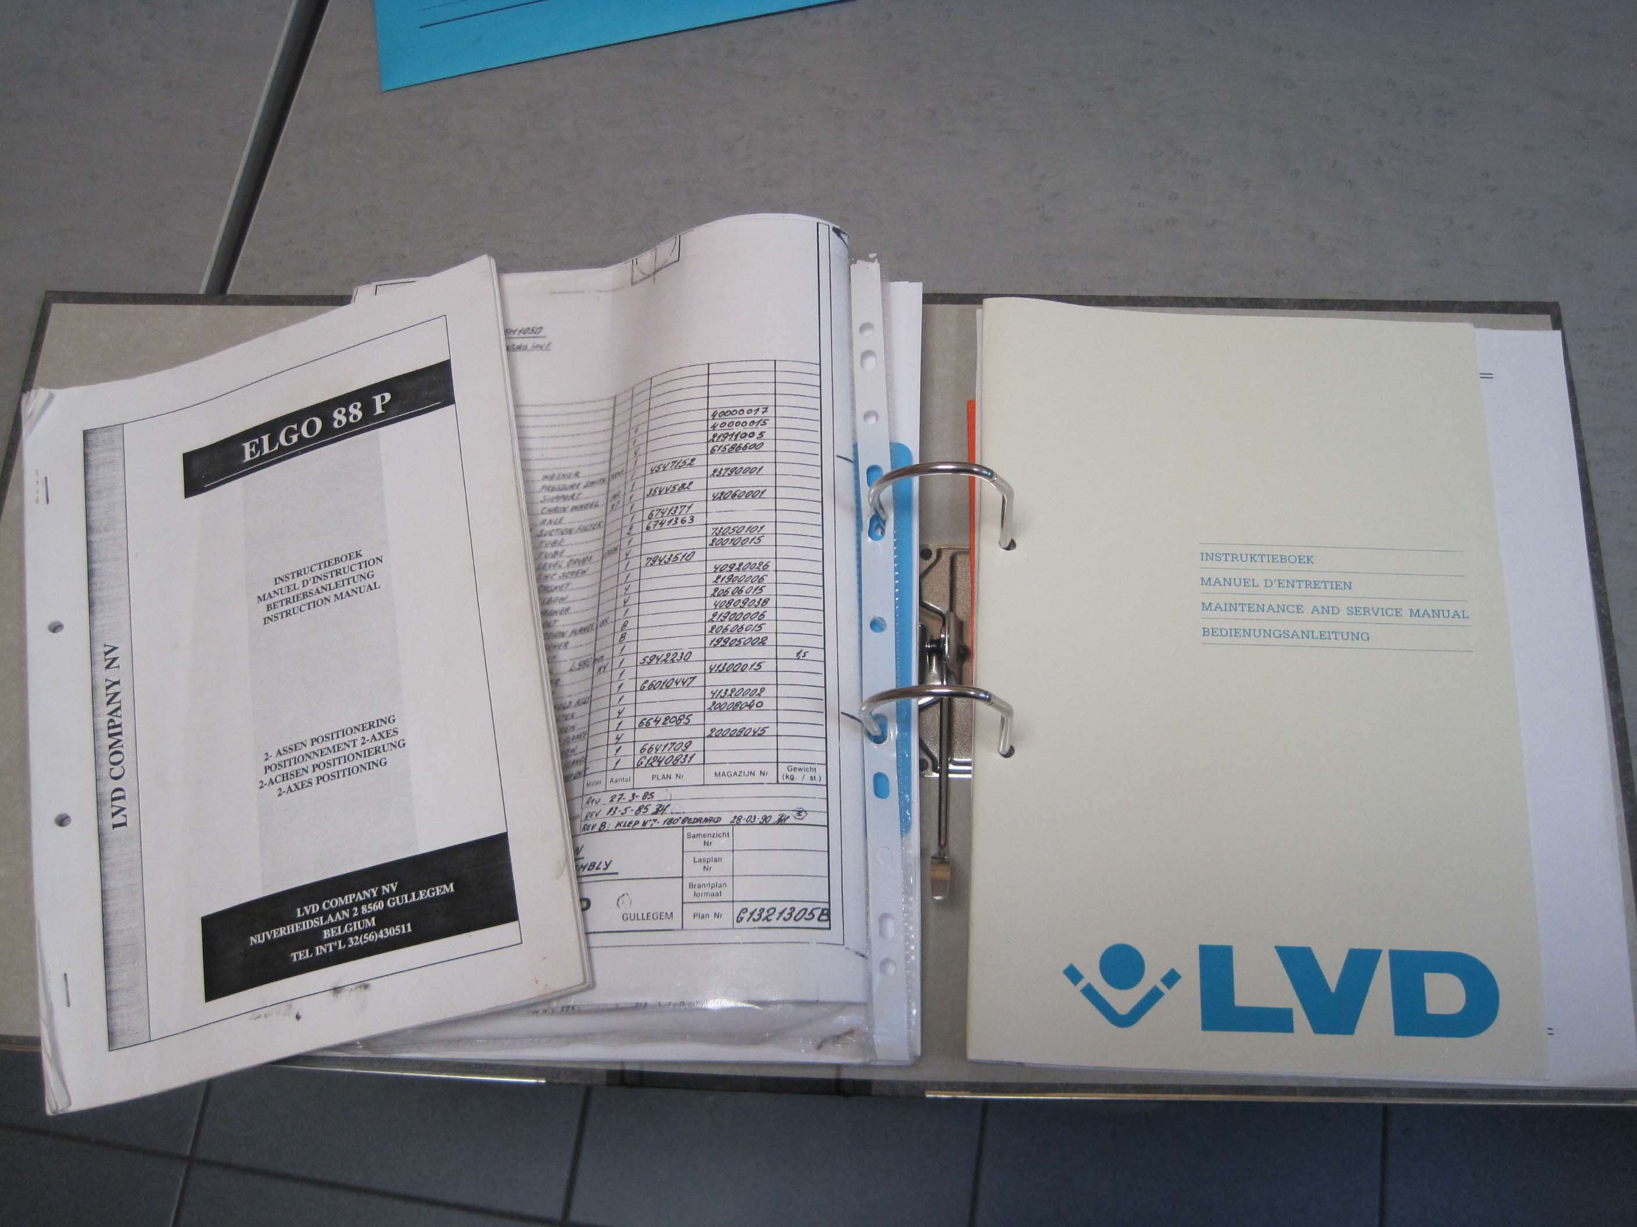
- Incl. documantation

- Very little used !

Please Note: The above information has been obtained to the best of our ability and belief from, and from the manufacturers where possible. It is given in good faith, but its accuracy can not be guaranteed. Accordingly, it will not form a representation or constitute contractual terms. We advise you to check any vital details!

